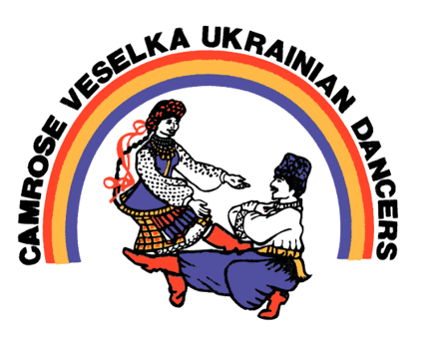

Camrose Veselka Ukrainian Dancers

Camrose, Alberta

Malanka Silent Auction - Letter of Inquiry

To Whom it may concern,

Camrose Veselka Ukrainian Dance Society is a non-profit that allows children and adults alike to enjoy, share, and preserve Ukrainian culture through dance.

Malanka, or Ukrainian New Year’s, will be hosted by Veselka on January 25th and includes performances by all our dancers, a Ukrainian meal, and a night of dancing to live music. It is also one of our biggest fundraisers of the year. Fundraising allows us to buy costumes, send dancers to festivals, and to keep registration costs as low as possible so that everyone can enjoy Ukrainian dance.

On behalf of the Camrose Veselka Ukrainian Dancers, I am requesting that you help us in our fundraising by donating an item or gift card to be sold at our Malanka silent auction. If you are able to do so, please attach a business card along with your donation and the approximate value of the item, and arrange a pick-up before January 8th.

Please contact us here if you are able to donate: _________________________

We greatly appreciate your support and thank you for your contribution to preserving Ukrainian culture in Camrose.

Sincerely,

Camrose Veselka Ukrainian Dance Society